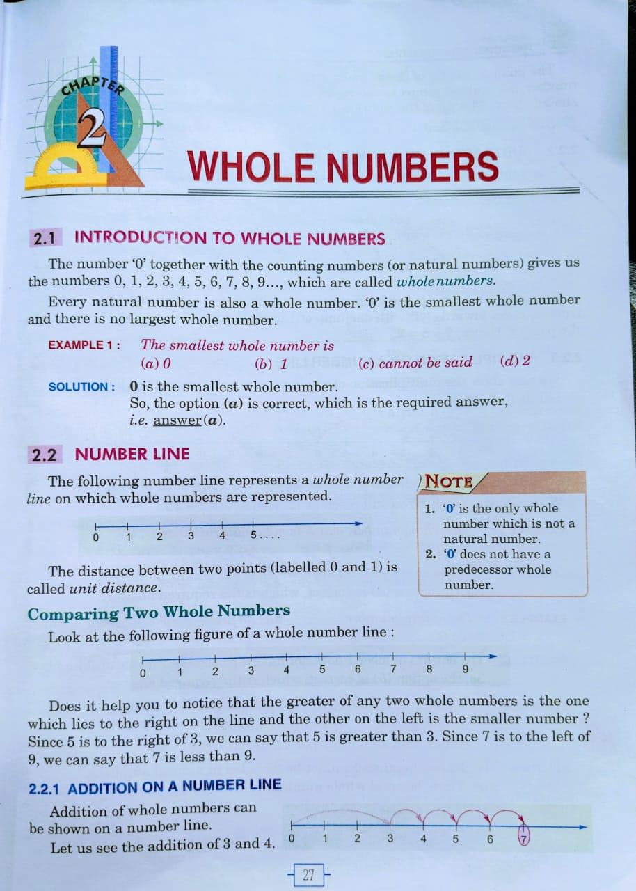

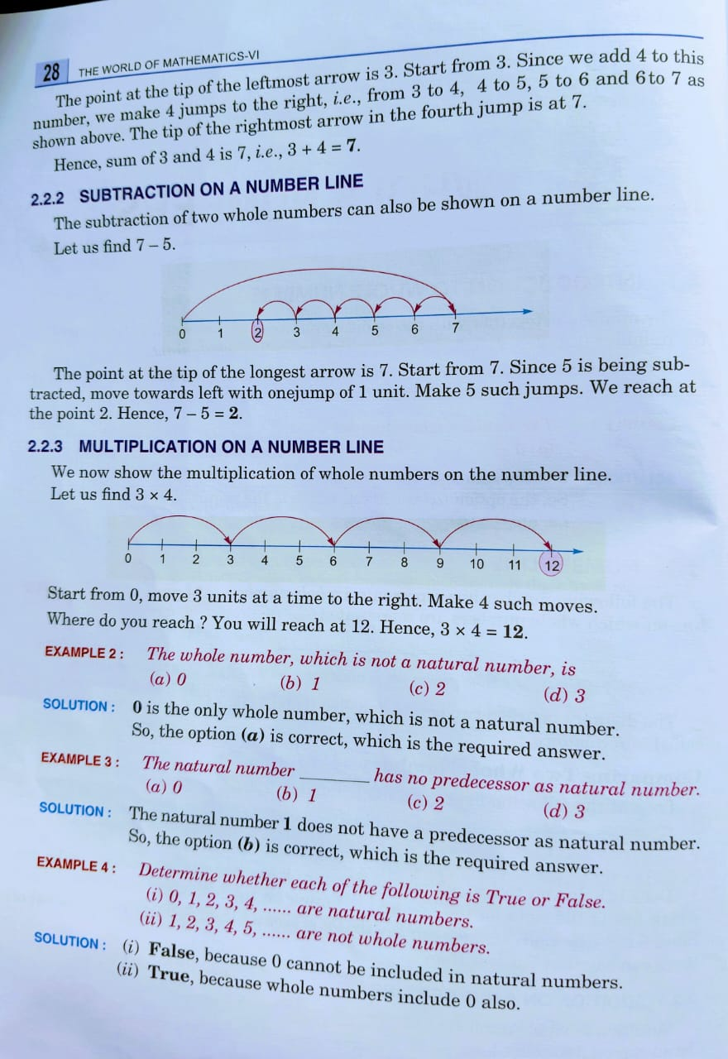

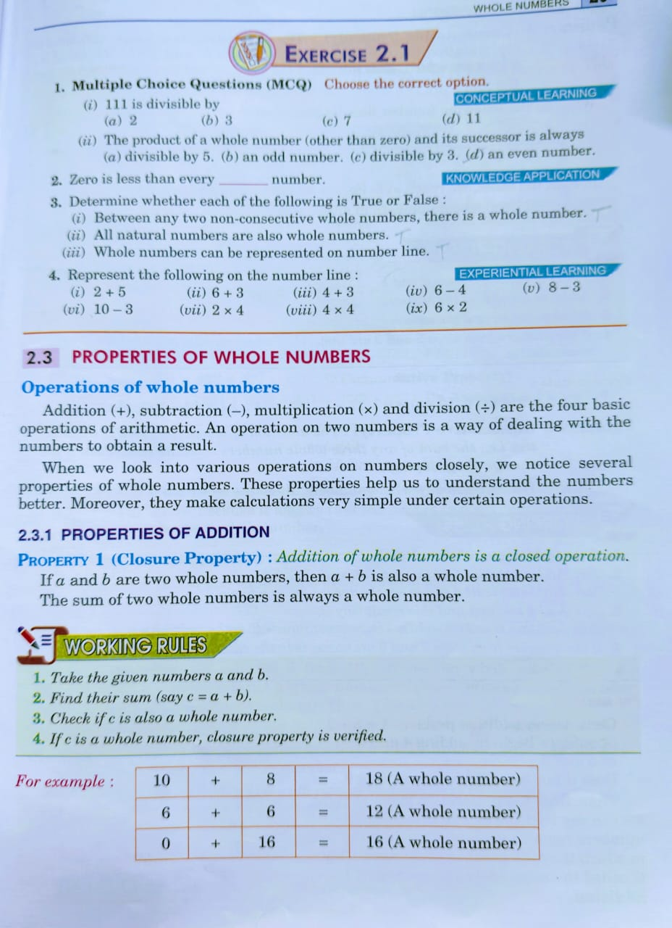

**1. Multiple Choice Questions (MCQ)**

**(i)** 111 is divisible by  
**Answer:** (b) **3**  
*Explanation:* 1 + 1 + 1 = 3, which is divisible by 3.

**(ii)** The product of a whole number (other than zero) and its successor is always  
**Answer:** (d) **an even number**  
*Explanation:* One of the two consecutive numbers is always even.

**2. Fill in the Blank**

Zero is less than every **natural** number.

**3. Determine whether the following are True or False:**

**(i)** Between any two non-consecutive whole numbers, there is a whole number.  
**Answer:** **True**

**(ii)** All natural numbers are also whole numbers.  
**Answer:** **True**  
*(Whole numbers start from 0, natural numbers from 1)*

**(iii)** Whole numbers can be represented on a number line.  
**Answer:** **True**

**4. Represent the following on the number line:**

You can draw a straight line with marks from 0 to at least 12 and show jumps for the operations:

**(i)** 2 + 5 → Start at 2, move 5 steps forward → Land at **7**  
**(ii)** 6 + 3 → Start at 6, move 3 steps forward → Land at **9**  
**(iii)** 4 + 3 → Start at 4, move 3 steps forward → Land at **7**  
**(iv)** 6 - 4 → Start at 6, move 4 steps backward → Land at **2**  
**(v)** 8 - 3 → Start at 8, move 3 steps backward → Land at **5**  
**(vi)** 10 - 3 → Start at 10, move 3 steps backward → Land at **7**  
**(vii)** 2 × 4 → Repeated addition: 2 + 2 + 2 + 2 = **8**  
**(viii)** 4 × 4 → 4 + 4 + 4 + 4 = **16**  
**(ix)** 6 × 2 → 6 + 6 = **12**

Would you like number line diagrams for these too?

4o

**You said:**

Yes

**ChatGPT said:**

Here are the number line representations for the given operations:

**Addition on a Number Line**

1. **2 + 5**
   * Start at **2**.
   * Move **5** steps forward.
   * Land at **7**.
2. **6 + 3**
   * Start at **6**.
   * Move **3** steps forward.
   * Land at **9**.
3. **4 + 3**
   * Start at **4**.
   * Move **3** steps forward.
   * Land at **7**.

**Subtraction on a Number Line**

1. **6 - 4**
   * Start at **6**.
   * Move **4** steps backward.
   * Land at **2**.
2. **8 - 3**
   * Start at **8**.
   * Move **3** steps backward.
   * Land at **5**.
3. **10 - 3**
   * Start at **10**.
   * Move **3** steps backward.
   * Land at **7**.

**Multiplication on a Number Line (Repeated Addition)**

1. **2 × 4** (2 groups of 4)
   * Jumps of **2** (4 times): **0 → 2 → 4 → 6 → 8**
2. **4 × 4** (4 groups of 4)
   * Jumps of **4** (4 times): **0 → 4 → 8 → 12 → 16**
3. **6 × 2** (6 groups of 2)
   * Jumps of **6** (2 times): **0 → 6 → 12**

**Exercise 2.2**

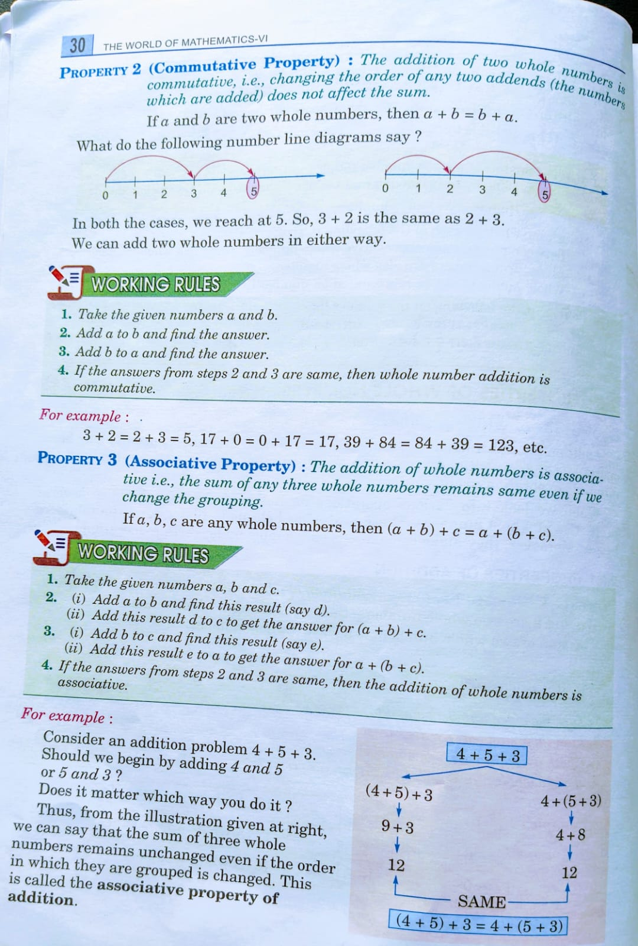

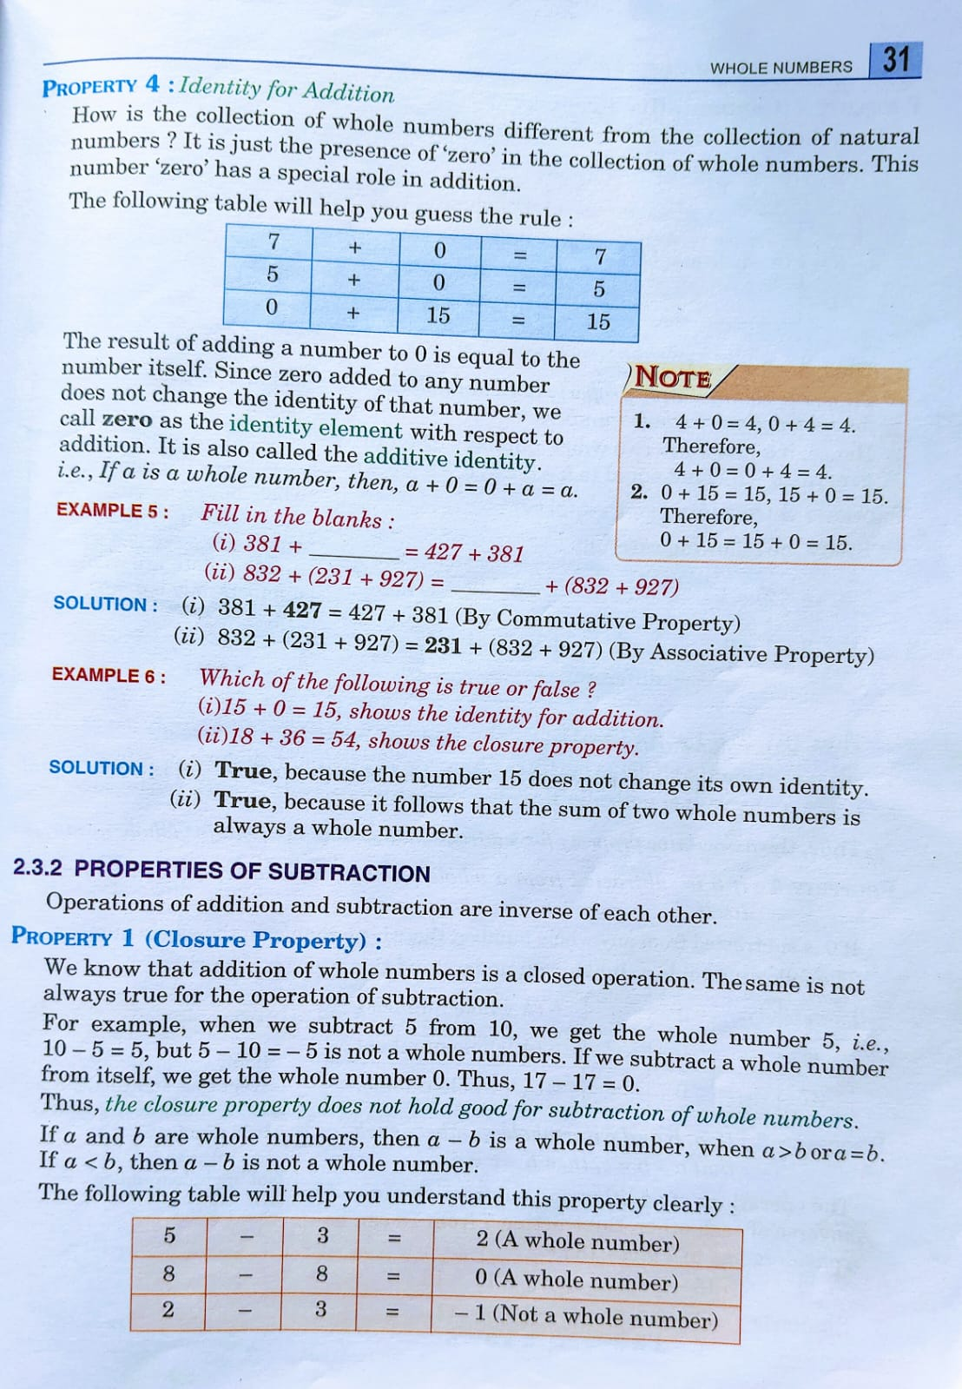

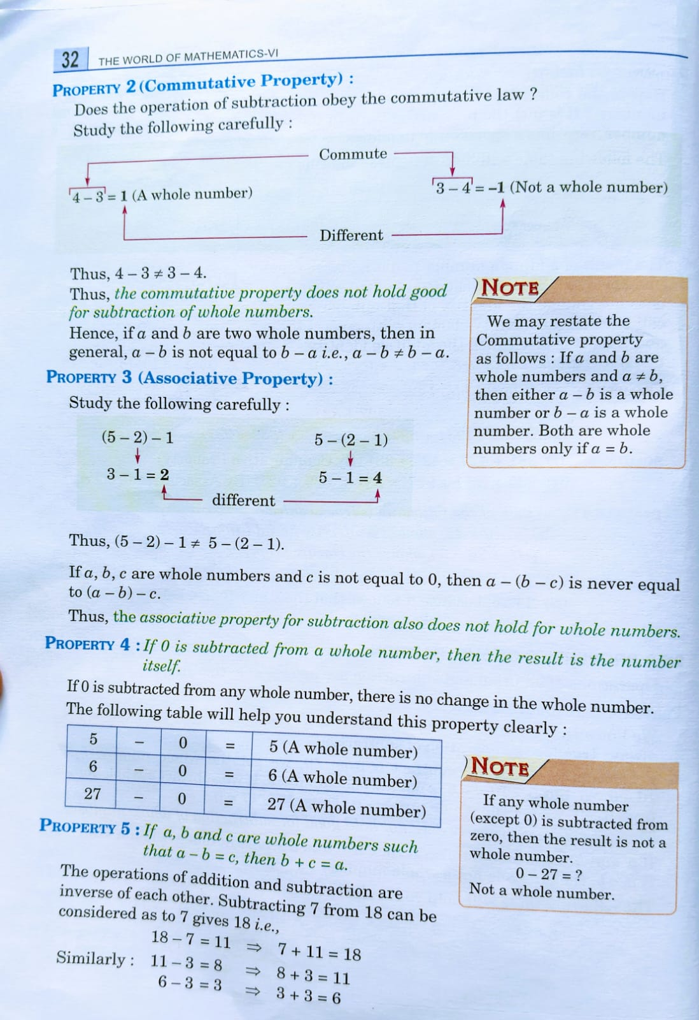

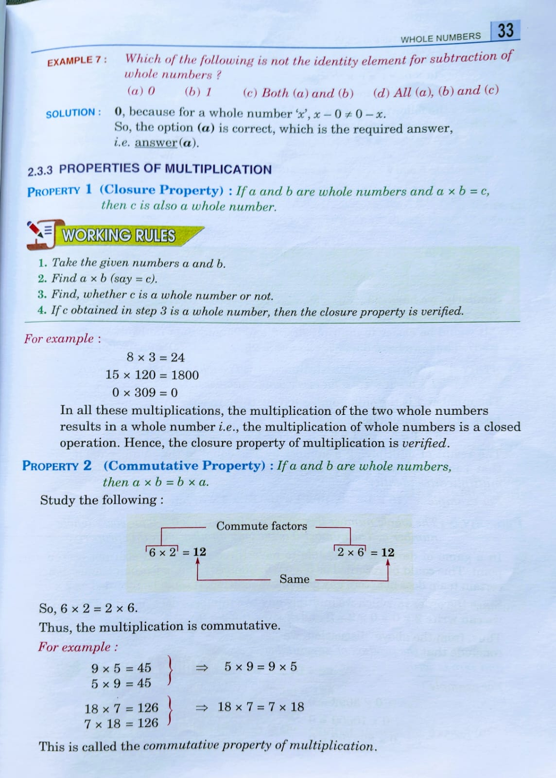

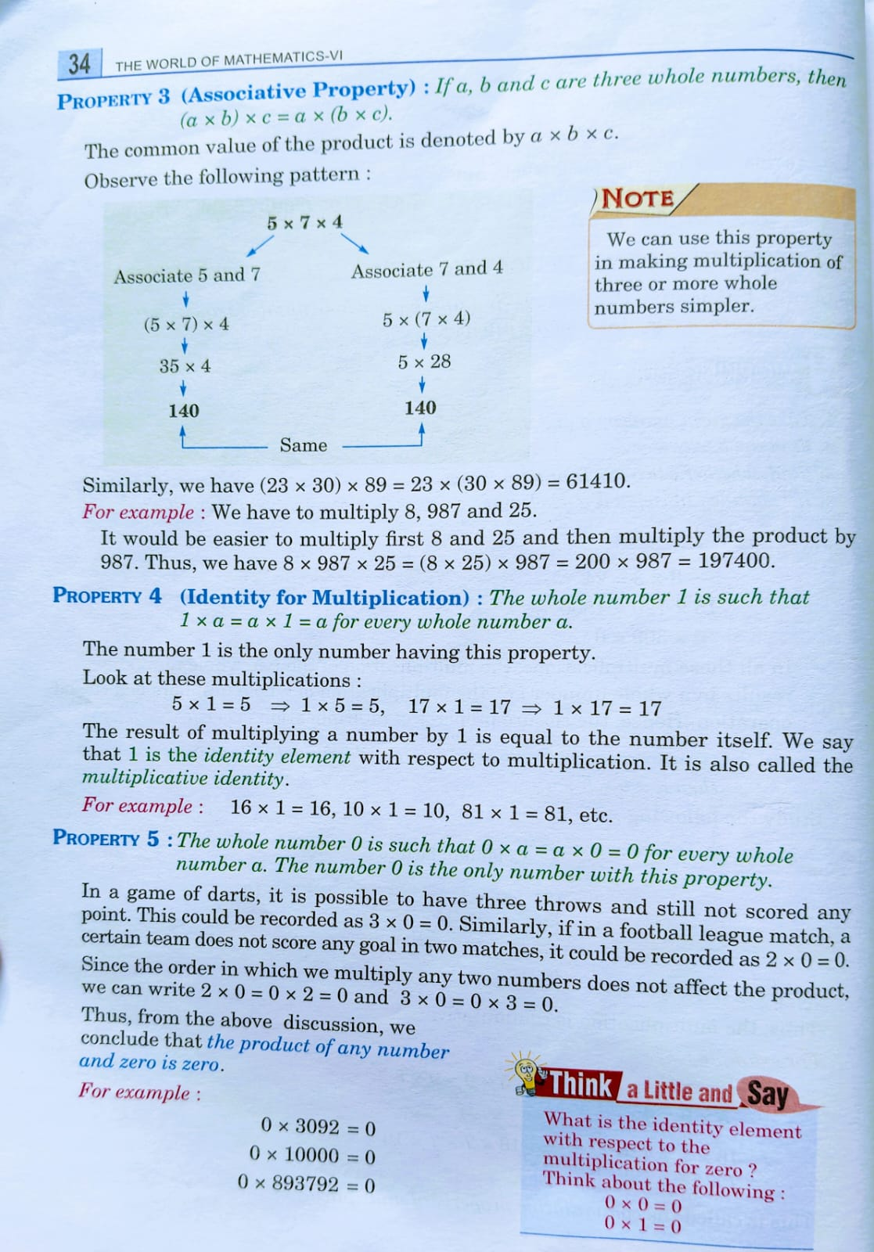

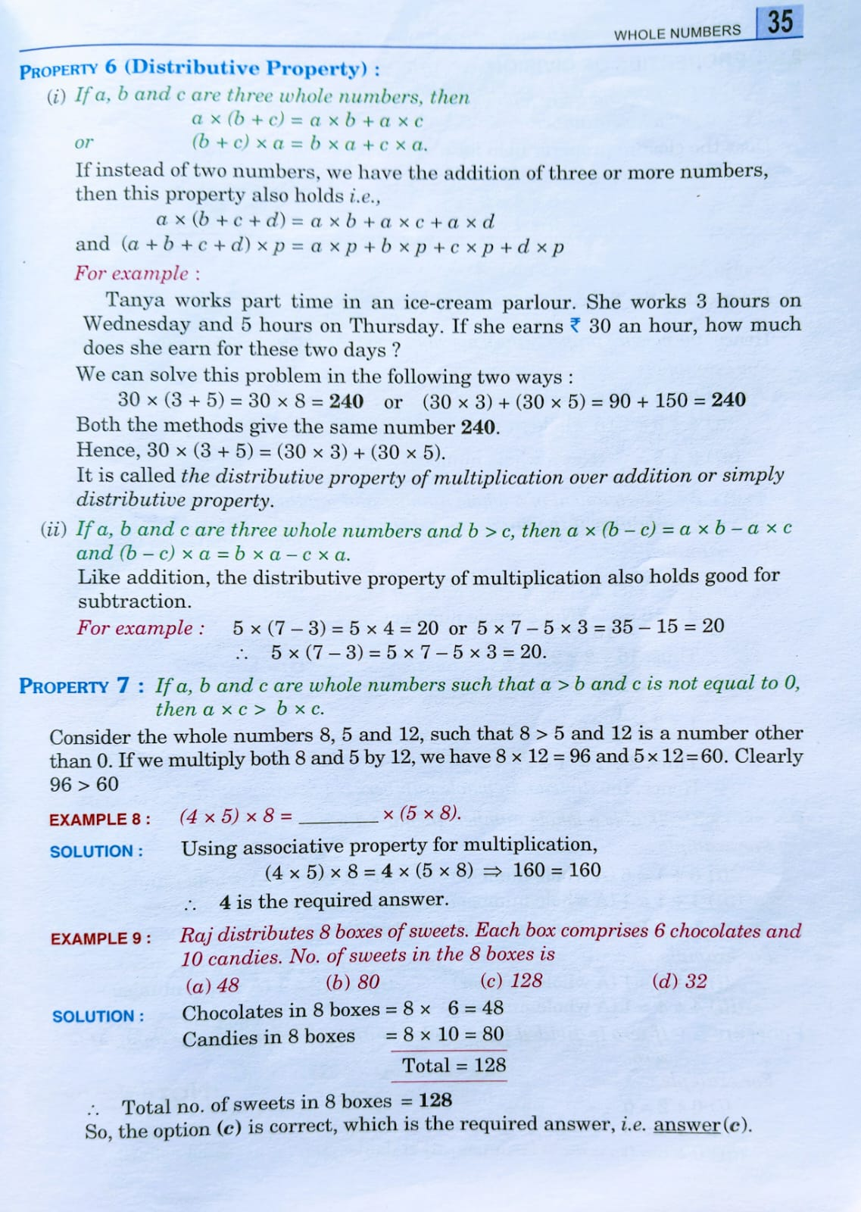

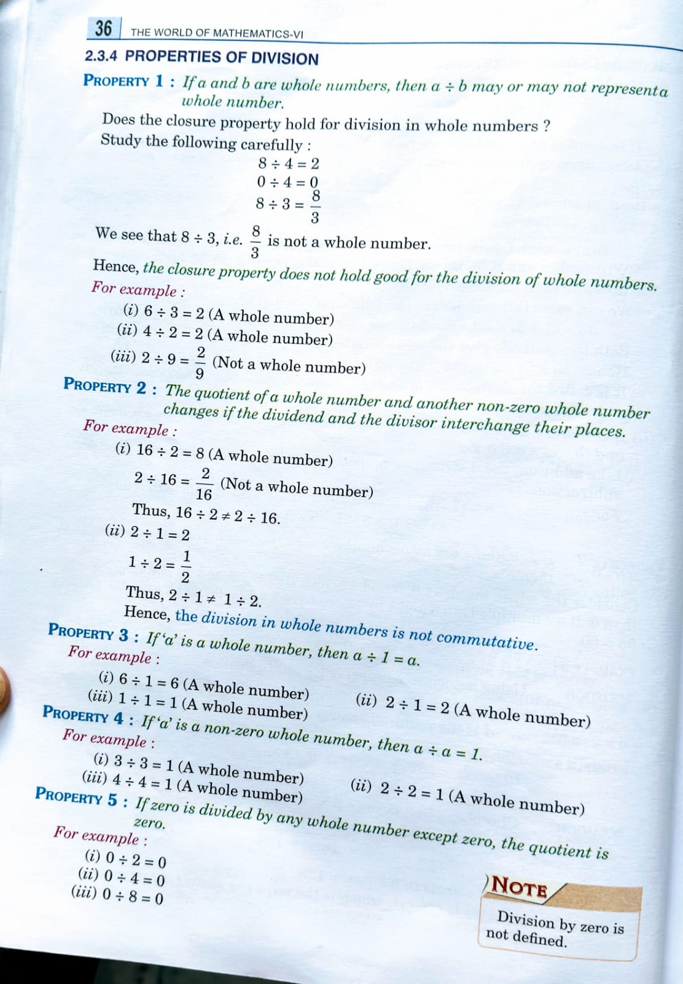

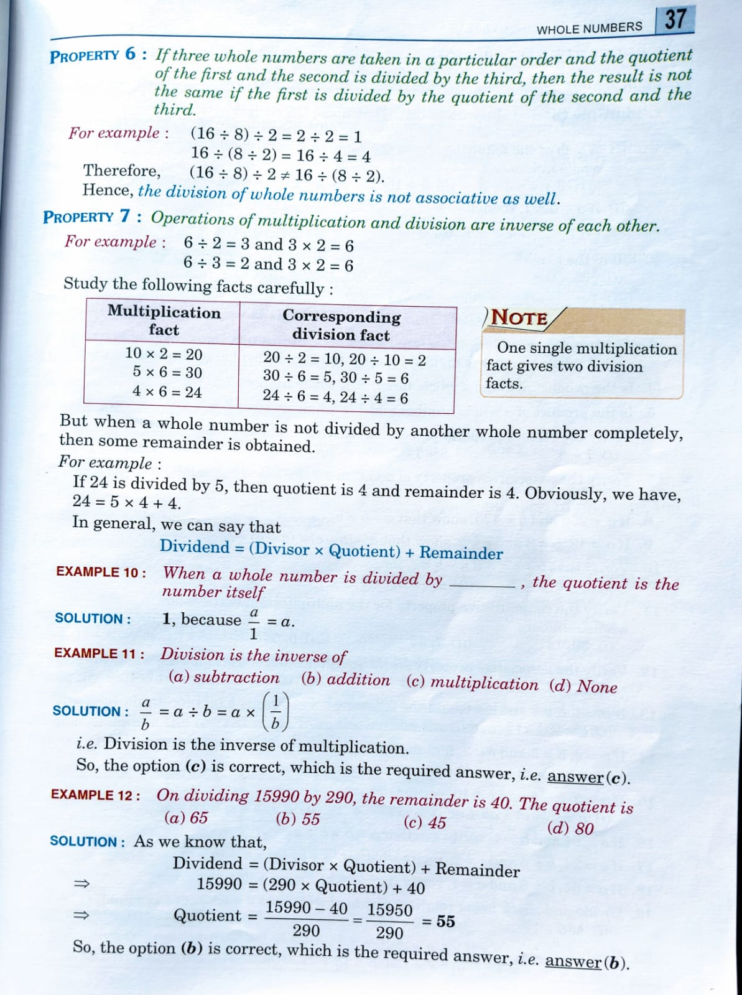

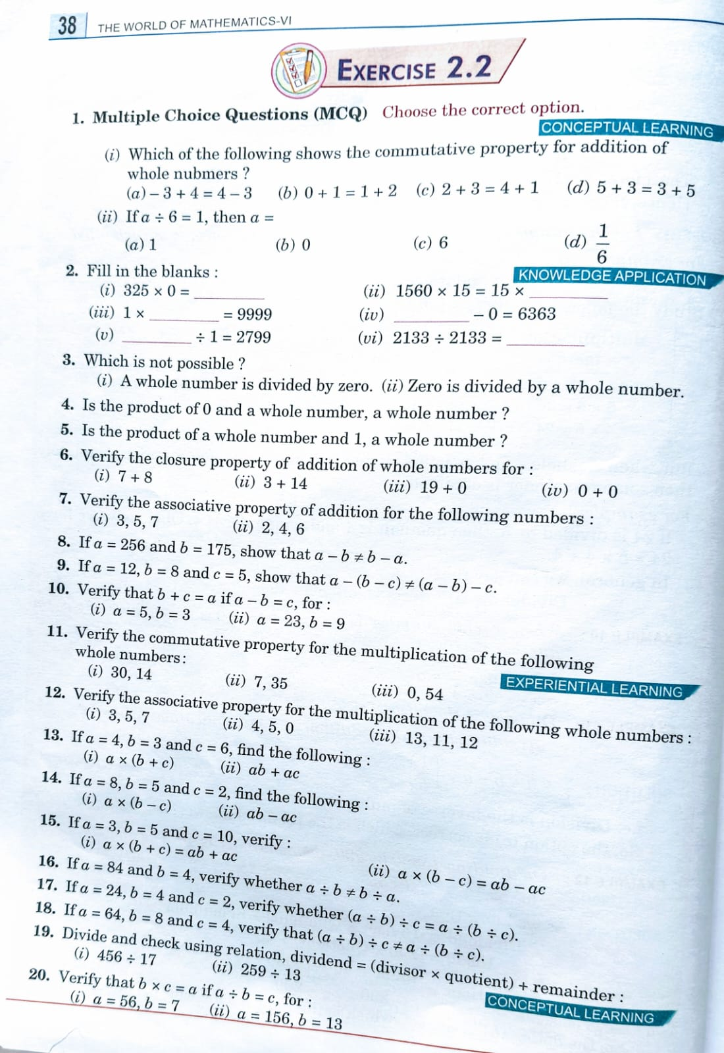

### ****1. MCQ: Choose the correct option****

**(i)** Which shows the commutative property for addition of whole numbers?  
**Answer:** (d) **5 + 3 = 3 + 5**

**(ii)** If a ÷ 6 = 1, then a =  
**Answer:** (c) **6**

### ****2. Fill in the blanks****

(i) 325 × 0 = **0**  
(ii) 1560 × 15 = 15 × **1560**  
(iii) 1 × **9999** = 9999  
(iv) **6363** − 0 = 6363  
(v) **2799** ÷ 1 = 2799  
(vi) 2133 ÷ 2133 = **1**

### ****3. Which is not possible?****

**Answer:** (i) A whole number is divided by zero — **Not possible**  
(ii) Zero is divided by a whole number — **Possible**

### ****4. Is the product of 0 and a whole number, a whole number?****

**Answer:** **Yes**

### ****5. Is the product of a whole number and 1, a whole number?****

**Answer:** **Yes**

### ****6. Verify the closure property of addition of whole numbers****

**Closure property:** The sum of two whole numbers is a whole number.  
(i) 7 + 8 = **15** → whole number  
(ii) 3 + 14 = **17** → whole number  
(iii) 19 + 0 = **19** → whole number  
(iv) 0 + 0 = **0** → whole number

**Verified**

### ****7. Verify associative property of addition****

Associative: (a + b) + c = a + (b + c)

**(i)** 3, 5, 7  
(3 + 5) + 7 = 8 + 7 = **15**  
3 + (5 + 7) = 3 + 12 = **15**

**(ii)** 2, 4, 6  
(2 + 4) + 6 = 6 + 6 = **12**  
2 + (4 + 6) = 2 + 10 = **12**

**Verified**

### ****8. Show that a - b ≠ b - a, where a = 256, b = 175****

a − b = 256 − 175 = **81**  
b − a = 175 − 256 = **Not a whole number**  
**Verified: a − b ≠ b − a**

### ****9. Show that a − (b − c) ≠ (a − b) − c for a = 12, b = 8, c = 5****

a − (b − c) = 12 − (8 − 5) = 12 − 3 = **9**  
(a − b) − c = (12 − 8) − 5 = 4 − 5 = **Not a whole number**  
**Verified**

### ****10. Verify b + c = a if a − b = c****

**(i)** a = 5, b = 3 → c = a − b = 2  
→ b + c = 3 + 2 = **5 = a** ✔

**(ii)** a = 23, b = 9 → c = 14  
→ b + c = 9 + 14 = **23 = a** ✔

**Verified**

### ****11. Verify commutative property for multiplication****

**(i)** 30 × 14 = **420**, 14 × 30 = **420** ✔  
**(ii)** 7 × 35 = **245**, 35 × 7 = **245** ✔  
**(iii)** 0 × 54 = **0**, 54 × 0 = **0** ✔

**Verified**

### ****12. Verify associative property for multiplication****

**(i)** 3, 5, 7  
(3 × 5) × 7 = 15 × 7 = **105**  
3 × (5 × 7) = 3 × 35 = **105** ✔

**(ii)** 4, 5, 0  
(4 × 5) × 0 = 20 × 0 = **0**  
4 × (5 × 0) = 4 × 0 = **0** ✔

**(iii)** 13, 11, 12  
(13 × 11) × 12 = 143 × 12 = **1716**  
13 × (11 × 12) = 13 × 132 = **1716** ✔

**Verified**

### ****13. a = 4, b = 3, c = 6****

(i) a × (b + c) = 4 × (3 + 6) = 4 × 9 = **36**  
(ii) ab + ac = 4×3 + 4×6 = 12 + 24 = **36** ✔

### ****14. a = 8, b = 5, c = 2****

(i) a × (b − c) = 8 × (5 − 2) = 8 × 3 = **24**  
(ii) ab − ac = 8×5 − 8×2 = 40 − 16 = **24** ✔

### ****15. a = 3, b = 5, c = 10****

(i) a × (b + c) = 3 × (5 + 10) = 3 × 15 = **45**  
ab + ac = 3×5 + 3×10 = 15 + 30 = **45** ✔

(ii) a × (b − c) = 3 × (5 − 10) = 3 × (−5) = **−15**  
ab − ac = 3×5 − 3×10 = 15 − 30 = **−15** ✔

### ****16. a = 84, b = 4****

a ÷ b = 84 ÷ 4 = **21**  
b ÷ a = 4 ÷ 84 = **Not a whole number**  
**Verified: a ÷ b ≠ b ÷ a**

### ****17. a = 24, b = 4, c = 2****

(a ÷ b) ÷ c = (24 ÷ 4) ÷ 2 = 6 ÷ 2 = **3**  
a ÷ (b ÷ c) = 24 ÷ (4 ÷ 2) = 24 ÷ 2 = **12**  
**Not equal**

### ****18. a = 64, b = 8, c = 4****

(a ÷ b) ÷ c = (64 ÷ 8) ÷ 4 = 8 ÷ 4 = **2**  
a ÷ (b ÷ c) = 64 ÷ (8 ÷ 4) = 64 ÷ 2 = **32**  
**Not equal**

### ****19. Divide and check using: Dividend = Divisor × Quotient + Remainder****

**(i)** 456 ÷ 17  
→ Quotient = **26**, Remainder = **14**  
Check: 17 × 26 + 14 = 442 + 14 = **456** ✔

**(ii)** 259 ÷ 13  
→ Quotient = **19**, Remainder = **12**  
Check: 13 × 19 + 12 = 247 + 12 = **259** ✔

### ****20. Verify b × c = a if a ÷ b = c****

**(i)** a = 56, b = 7 → a ÷ b = 8  
→ b × c = 7 × 8 = **56 = a** ✔

**(ii)** a = 156, b = 13 → a ÷ b = 12  
→ b × c = 13 × 12 = **156 = a** ✔

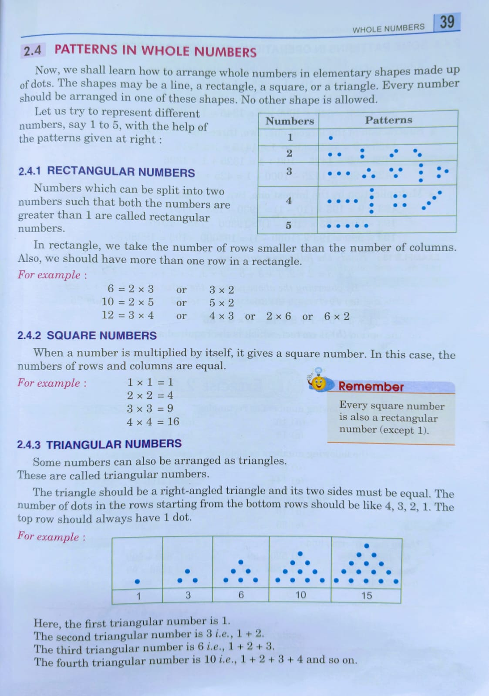

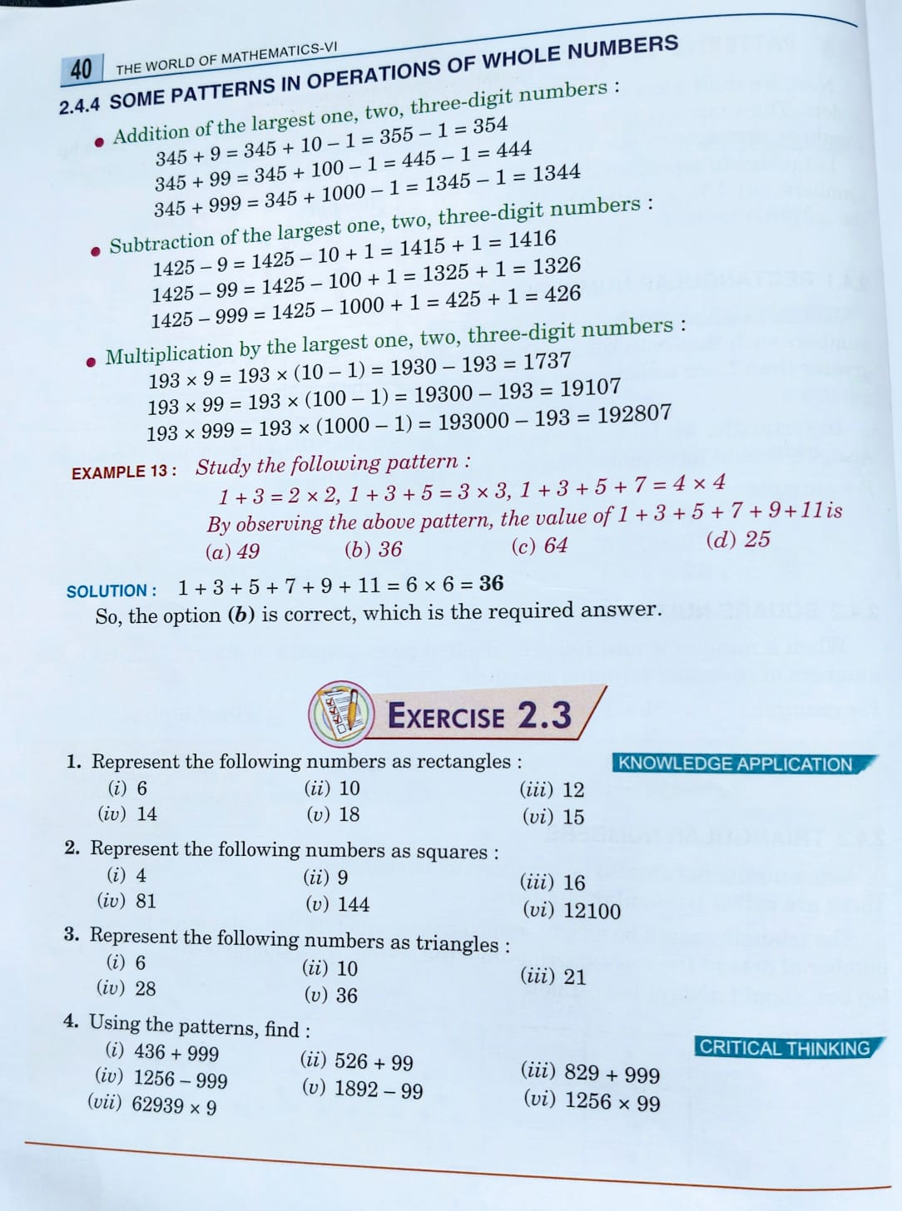

**Exercise 2.3**

**1. Representing Numbers as Rectangles**

A **rectangle** has different possible length-width pairs. Represent each number as a product of two factors:

* **6** → 2×3
* **10** → 2×5
* **12** → 3×4 or 2×6
* **14** → 2×7
* **18** → 3×6 or 2×9
* **15** → **2.** 
  1. **Representing Numbers as Squares:**

A **square number** is the product of a number multiplied by itself:

* **4** → 2×2
* **9** → 3×3
* **16** → 4×4
* **81** → 9×9
* **144** → 12×12
* **12100** → 110×110

**3. Representing Numbers as Triangles:**

A **triangular number** follows the formula Tn=n(n+1)/2​:

* **6** → T3=3+2+1
* **10** → T4=4+3+2+1
* **21** → T6=6+5+4+3+2+1
* **28** → T7=7+6+5+4+3+2+1
* **36** → T8=8+7+6+5+4+3+2+1

**4. Pattern-Based Calculations**

Using number patterns for simplification:

* **(i) 436 + 999** = 436+(1000−1)=1436−1=1435
* **(ii) 526 + 99** = 526+(100−1)=626−1=625
* **(iii) 829 + 999** = 829+(1000−1)=1829−1=1828
* **(iv) 1256 - 999** = 1256−(1000−1)=256+1=257
* **(v) 1892 - 99** = 1892−(100−1)=1792+1=1793
* **(vi) 1256 × 99** = 1256×(100−1)=125600−1256=124344
* **(vii) 62939 × 9** = 62939×(10−1)=629390−62939=566451

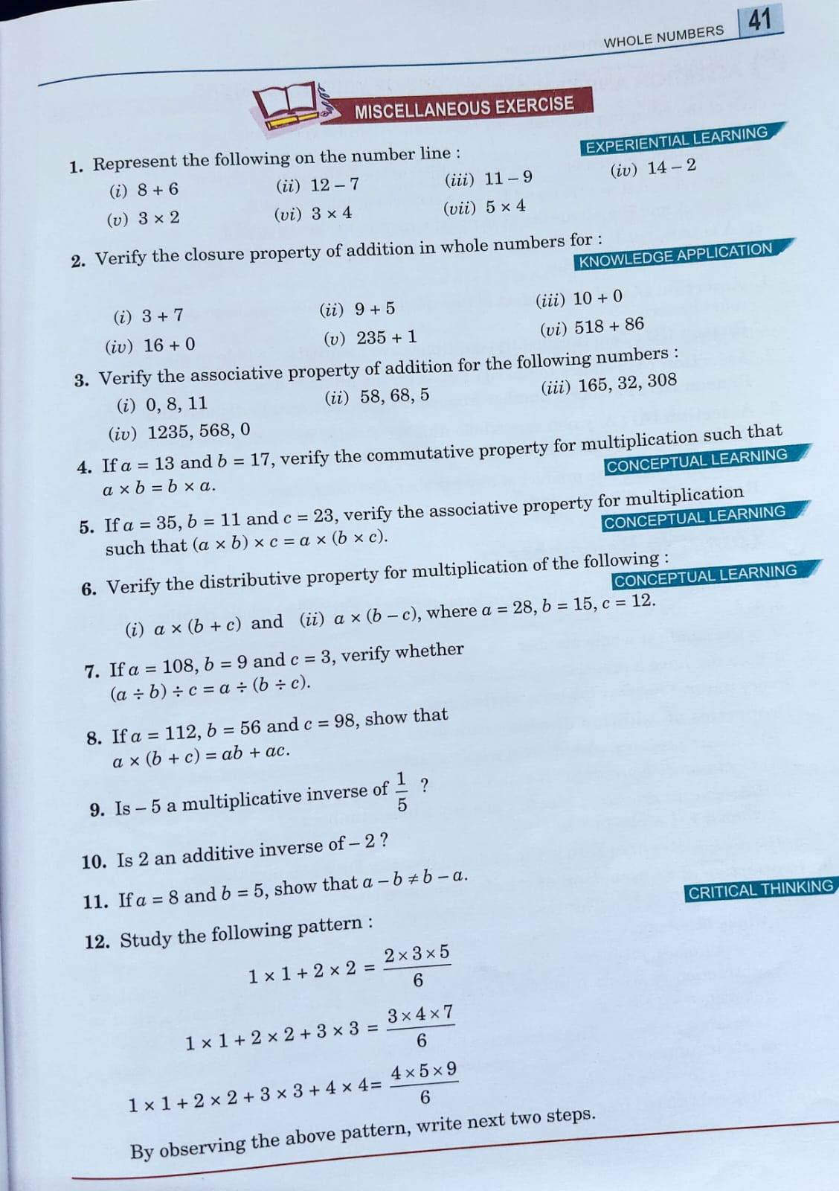

**1. Representing on the Number Line**

To represent these on a number line, follow these steps:

* **(i) 8 + 6** → Start at **8**, move **6** steps forward → **Result: 14**
* **(ii) 12 - 7** → Start at **12**, move **7** steps backward → **Result: 5**
* **(iii) 11 - 9** → Start at **11**, move **9** steps backward → **Result: 2**
* **(iv) 14 - 2** → Start at **14**, move **2** steps backward → **Result: 12**
* **(v) 3 × 2** → Start at **0**, move in steps of **3**, two times → **Result: 6**
* **(vi) 3 × 4** → Start at **0**, move in steps of **3**, four times → **Result: 12**
* **(vii) 5 × 4** → Start at **0**, move in steps of **5**, four times → **Result: 20**

**2. Closure Property of Addition in Whole Numbers**

Closure property states that the sum of two whole numbers is always a whole number.

* **(i) 3 + 7 = 10** (Whole number ✅)
* **(ii) 9 + 5 = 14** (Whole number ✅)
* **(iii) 10 + 0 = 10** (Whole number ✅)
* **(iv) 16 + 0 = 16** (Whole number ✅)
* **(v) 235 + 1 = 236** (Whole number ✅)
* **(vi) 518 + 86 = 604** (Whole number ✅)

Since all sums are whole numbers, **closure property holds true**.

**3. Associative Property of Addition**

Associative property states that for any whole numbers **a, b, c**:

(a+b)+c=a+(b+c)(a + b) + c = a + (b + c)(a+b)+c=a+(b+c)

* **(i) (0 + 8) + 11 = 8 + 11 = 19**  
  **0 + (8 + 11) = 0 + 19 = 19** ✅
* **(ii) (58 + 68) + 5 = 126 + 5 = 131**  
  **58 + (68 + 5) = 58 + 73 = 131** ✅
* **(iii) (165 + 32) + 308 = 197 + 308 = 505**  
  **165 + (32 + 308) = 165 + 340 = 505** ✅
* **(iv) (1235 + 568) + 0 = 1803 + 0 = 1803**  
  **1235 + (568 + 0) = 1235 + 568 = 1803** ✅

**Associative property verified!**

**4. Commutative Property of Multiplication**

Commutative property states:

a×b=b×a

For **a = 13, b = 17**:

13×17=221

17×13=221

✅ **Property holds true**.

**5. Associative Property of Multiplication**

Associative property states:

(a×b)×c=a×(b×c)

For **a = 35, b = 11, c = 23**:

(35×11)×23=385×23=8855

35×(11×23)=35×253=88555

✅ **Property holds true**.

**6. Distributive Property**

Distributive property states:

a×(b+c)=(a×b)+(a×c)

a×(b−c)=(a×b)−(a×c)

For **a = 28, b = 15, c = 12**:

28×(15+12)=28×27=756

(28×15)+(28×12)=420+336=756

✅ **Distributive property holds**.

**7. Division Associativity**

We check:

(a÷b)÷c=a÷(b÷c)

For **a = 108, b = 9, c = 3**:

(108÷9)÷3=12÷3=4

108÷(9÷3)=108÷3=36

❌ **Not equal! Associative property does not hold for division.**

**8. Distributive Property in Multiplication**

Check:

a×(b+c)=(a×b)+(a×c)

For **a = 112, b = 56, c = 98**:

112×(56+98)=112×154=17248

(112×56)+(112×98)=6272+10976=17248

✅ **Property holds true**.

**9. Multiplicative Inverse Check**

A **multiplicative inverse** of **x** is **1/x**.

For **-5** and **1/5**:

−5×1/5=−1

❌ **Not 1, so -5 is NOT the multiplicative inverse of 1/5.**

**10. Additive Inverse Check**

An **additive inverse** of **x** is **-x**.

For **2 and -2**:

2+(−2)=0

✅ **Yes, 2 is the additive inverse of -2.**

**11. Subtraction is Not Commutative**

To verify:

a−b≠b−a

For **a = 8, b = 5**:

8−5=3

5−8=−3

✅ **Not equal, so subtraction is NOT commutative.**

**12. Pattern Observation**

Given pattern:

12+22=2×3×5/6

​12+22+32=3×4×7/6

12+22+32+42=4×5×9/6

Observing the pattern, the general form is:

12+22+...+n2=n(n+1)(2n+1)/6

Next two steps:

12+22+32+42+52=5×6×11/ 6 =55

12+22+32+42+52+62=6×7×13/6=91

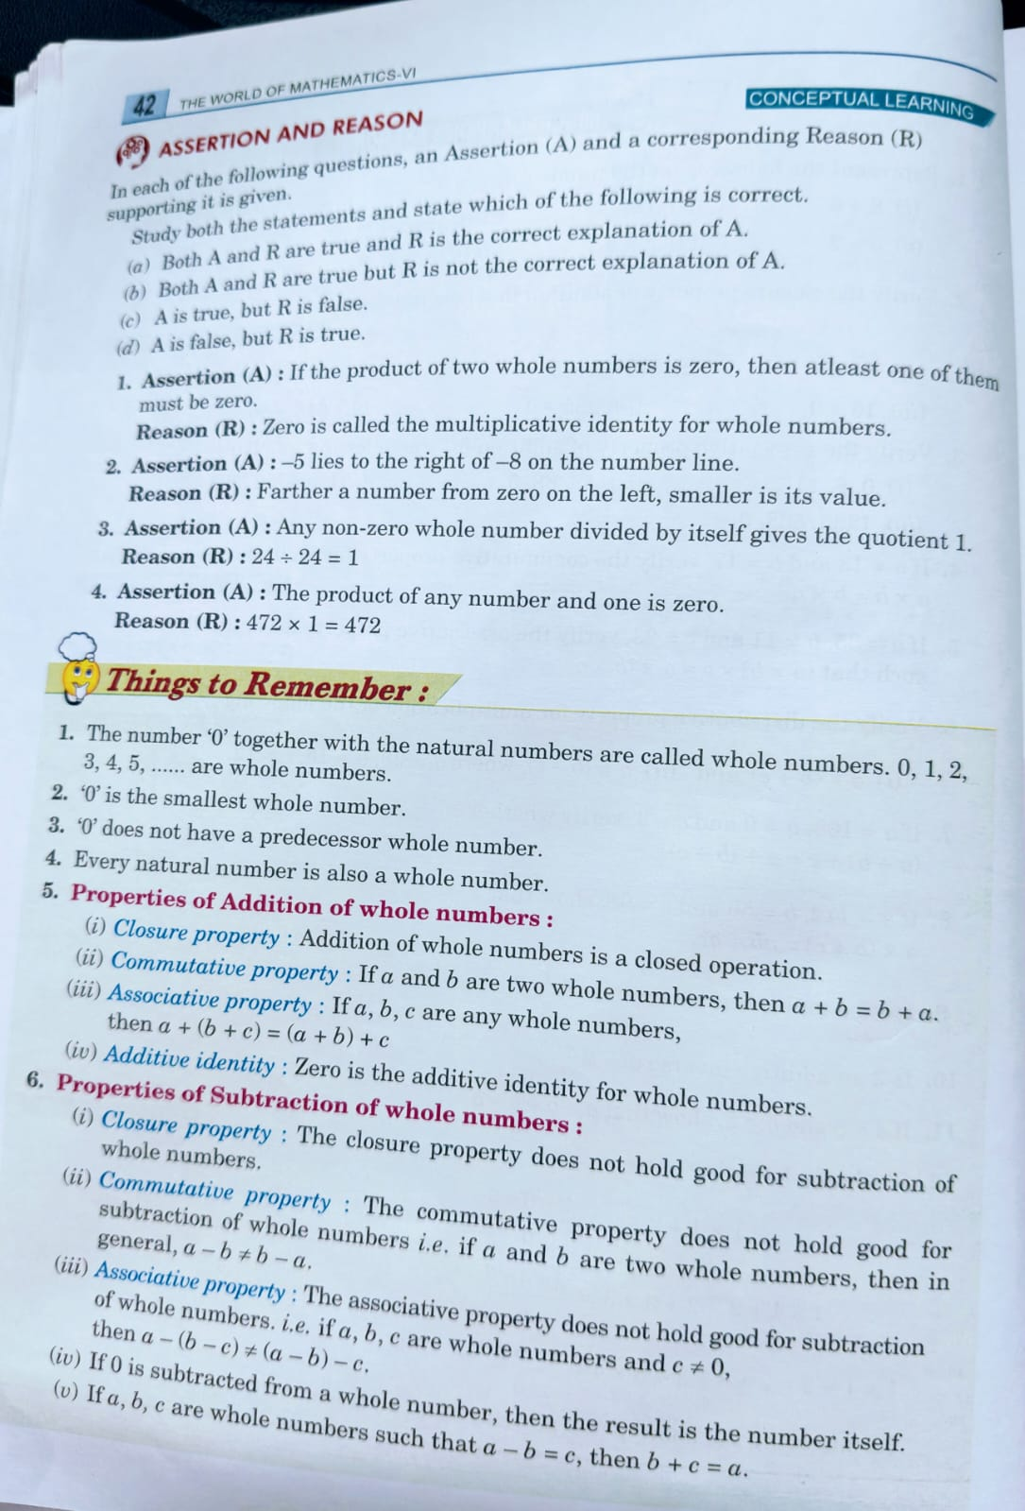

**c**

**b**

**a**

**d**

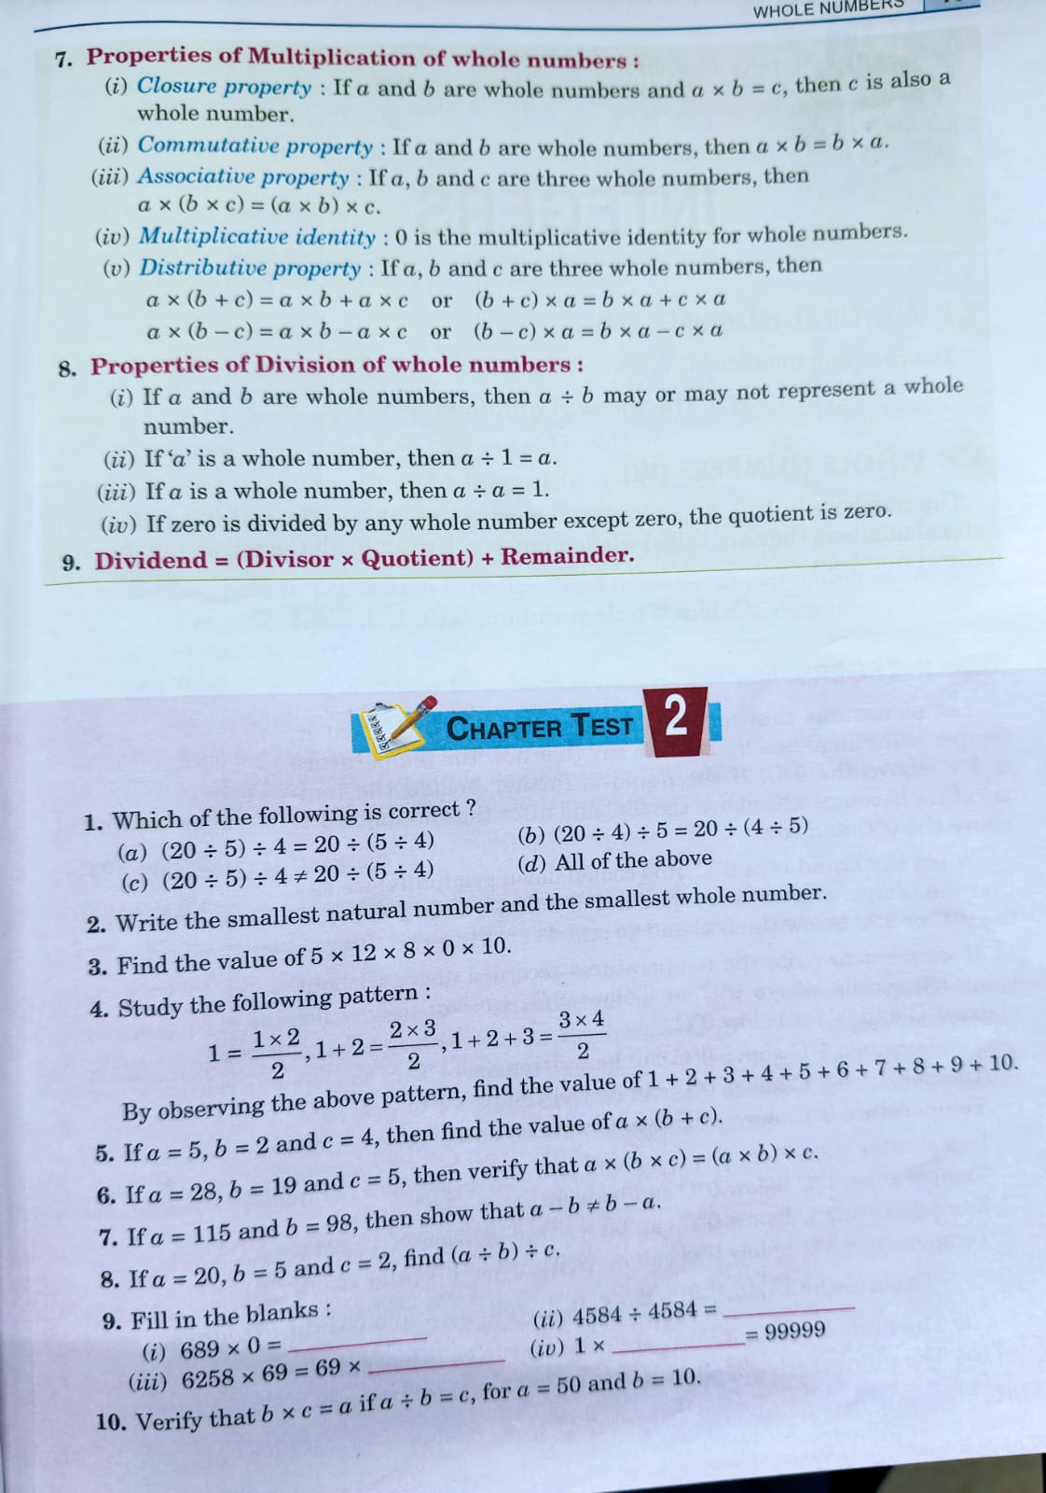

**Chapter test 2**

1. **Which of the following is correct?**
   * Option **(c)**

(20÷5)÷4=(4)÷4=1

20÷5÷4=4÷4=1

Since both sides are equal, option **(c) is correct**.

1. **Write the smallest natural number and the smallest whole number.**
   * The **smallest natural number** is **1**.
   * The **smallest whole number** is **0**.
2. **Find the value of 5×12×8×0×10.**
   * Any number multiplied by **0** results in **0**.
   * So, the answer is **0**.
3. **Study the given pattern:**
   * 1=(1x2)/2, 1+2=(2x3)/2 , 1+2+3= (3x4)/2 etc.
   * The sum of the first n natural numbers is given by the formula:

Sn=n(n+1)/2​

* + **For n=10,**

**S10= [10 x (10+1)] / 2 = 10×11/2= 110/2 = 55**

* + So, the sum is **55**.

1. **If c=28,b=19 and a=5, verify that a×(b+c)=(a×b)+(a×c) .**
   * LHS:

5×(19+28)=5×47=235

* + RHS:

(5×19)+(5×28)=95+140=235

* + Since LHS = RHS, the property is verified.

1. **If a=115 and b=98 , then verify that a×b=b×a .**
   * LHS: 115×98=11270
   * RHS: 98×115=11270
   * Since LHS = RHS, the property is verified.
2. **If a=20, b=5 and c=2, find (a+b)×c.**
   * (20+5)×2=25×2=50
   * Answer: **50**.
3. **Fill in the blanks:**
   * (i) 689×0=0
   * (ii) 6258×69=69×6258 (Commutative Property)
   * (iii) 4584÷4584=1
   * (iv) 1×99999=99999 .
4. **Verify that b×c=a if a=b×c for 5×2=10** 
   * 5×2=10 5 holds true. Hence, verification is complete.